# Rossmoyne Senior High School

### Semester One Examination, 2015

### Question/Answer Booklet

**SOLUTIONS**

# MATHEMATICS APPLICATIONS

# UNIT 1

## Section One:

## Calculator-free

|  |  |  |  |  |  |  |  |  |
| --- | --- | --- | --- | --- | --- | --- | --- | --- |
| Student Number: In figures |  |  |  |  |  |  |  |  |

In words

Your name

## Time allowed for this section

Reading time before commencing work: five minutes

Working time for this section: fifty minutes

## Materials required/recommended for this section

##### *To be provided by the supervisor*

This Question/Answer Booklet

Formula Sheet

##### *To be provided by the candidate*

Standard items: pens (blue/black preferred), pencils (including coloured), sharpener,

correction fluid/tape, eraser, ruler, highlighters

Special items: nil

## Important note to candidates

No other items may be taken into the examination room. It is **your** responsibility to ensure that you do not have any unauthorised notes or other items of a non-personal nature in the examination room. If you have any unauthorised material with you, hand it to the supervisor **before** reading any further.

## Structure of this paper

|  |  |  |  |  |  |
| --- | --- | --- | --- | --- | --- |
| Section | Number of questions available | Number of questions to be answered | Working time (minutes) | Marks available | Percentage of exam |
| Section One:  Calculator-free | 7 | 7 | 50 | 52 | 35 |
| Section Two:  Calculator-assumed | 12 | 12 | 100 | 98 | 65 |
|  | | | **Total** | 150 | 100 |

## Instructions to candidates

1. The rules for the conduct of Western Australian external examinations are detailed in the *Year 12 Information Handbook 2015*. Sitting this examination implies that you agree to abide by these rules.
2. Write your answers in this Question/Answer Booklet.
3. You must be careful to confine your response to the specific question asked and to follow any instructions that are specified to a particular question.
4. Spare pages are included at the end of this booklet. They can be used for planning your responses and/or as additional space if required to continue an answer.

* Planning: If you use the spare pages for planning, indicate this clearly at the top of the page.
* Continuing an answer: If you need to use the space to continue an answer, indicate in the original answer space where the answer is continued, i.e. give the page number. Fill in the number of the question that you are continuing to answer at the top of the page.

1. **Show all your working clearly**. Your working should be in sufficient detail to allow your answers to be checked readily and for marks to be awarded for reasoning. Incorrect answers given without supporting reasoning cannot be allocated any marks. For any question or part question worth more than two marks, valid working or justification is required to receive full marks. If you repeat any question, ensure that you cancel the answer you do not wish to have marked.
2. It is recommended that you **do not use pencil**, except in diagrams.
3. The Formula Sheet is **not** to be handed in with your Question/Answer Booklet.

Section One: Calculator-free (52 Marks)

This section has**seven (****7)** questions. Answer **all** questions. Write your answers in the spaces provided.

Working time for this section is 50 minutes.

Question 1 (7 marks)

(a) If , determine  when . (1 mark)



(b) Evaluate . (1 mark)



(c) If  determine

(i)  given that  and . (1 mark)



(ii)  given that  and . (2 marks)



(iii)  given that  and . (2 marks)



Question 2 (6 marks)

A young person who lives in a shared house with friends has just started a new job after leaving school and is drawing up a budget to see how much of their $480 weekly take home pay they can save for a holiday later in the year.

|  |  |  |  |
| --- | --- | --- | --- |
|  | Frequency of payment | | |
| Expense | Weekly ($) | Fortnightly ($) | Four Weekly ($) |
| Rent | **150** | 300 |  |
| Household bills | 35 |  |  |
| Food and toiletries | 115 |  |  |
| Mobile phone plan | **15** |  | 60 |
| Health insurance | **20** | 40 |  |
| Entertainment | 60 |  |  |
| Travel costs | 30 |  |  |
| Clothing | **25** |  | 100 |

(a) Convert the fortnightly and four weekly payments to weekly and write these figures in the weekly column of the table above. (2 marks)

(b) Name an expense from the table above that is an example of a fixed expense. (1 mark)

Rent. Household bills. Mobile phone plan.

Health insurance. Travel costs.

(c) Name an expense from the table above that is an example of a discretionary expense.

(1 mark)

Food and toiletries. Entertainment. Clothing.

(d) If the young person has no other expenses, calculate how much of their $480 weekly take home pay they can save for a holiday. (2 marks)



Question 3 (8 marks)

Consider the matrices .

(a) Determine . (1 mark)



(b) State the size of the row matrix. (1 mark)

Row matrix is  - a 1 by 2 matrix

(c) Calculate, where  is the identity matrix. (2 marks)



(d) Determine the values of  if . (2 marks)



(e) Calculate. (2 marks)



Question 4 (9 marks)

The table below has been created using the formula  to calculate the apparent temperature,  ºC, at a location where the temperature is  ºC and the wind speed is  m/s.

|  |  |  |  |  |  |  |
| --- | --- | --- | --- | --- | --- | --- |
| (ºC) | | (ºC) | | | | |
| 5 | 10 | 15 | 20 | 25 |
| (m/s) | 2 | 2.6 | **C** | 12.6 | 17.6 | 22.6 |
| 4 | 1.4 | 6.4 | 11.4 | 16.4 | 21.4 |
| 6 | -0.6 | 4.4 | 9.4 | 14.4 | 19.4 |
| 8 | -3.4 | 1.6 | 6.6 | 11.6 | 16.6 |
| 10 | **D** | -2 | 3 | 8 | 13 |

(a) For this location, state

(i)  when  ºC and  m/s. (1 mark)

21.4 ºC

(ii)  when  ºC and  ºC. (1 mark)

8 m/s

(b) What is the wind speed on a day when the apparent temperature is 5.6 ºC less than the temperature? (1 mark)

6 m/s

(c) Determine the values of C and D in the table above. (2 marks)



(d) Use one example to show that the formula  could also be used to create the table above. (2 marks)





Substitute and comment:



which is the same result as in table.

(e) Use one example to show that the formula  could **not** be used to create the table above. (2 marks)





Substitute and comment:



which is not same result as in table.

Question 5 (6 marks)

The table below shows the amount of three different foreign currencies than can be exchanged for 5, 10, 20, 50 and 100 Australian dollars.

|  |  |  |  |  |  |
| --- | --- | --- | --- | --- | --- |
| Foreign currency | Australian Dollars (A$) | | | | |
| 5 | 10 | 20 | 50 | 100 |
| Euro | 3.50 | 7.00 | 14.00 | 35.00 | 70.00 |
| British Pound | 2.50 | 5.00 | 10.00 | 25.00 | 50.00 |
| Hong Kong Dollar | 30.00 | 60.00 | 120.00 | 300.00 | 600.00 |

(a) How many Hong Kong Dollars can be exchanged for one Australian Dollar? (1 mark)



(b) How many Euros could be exchanged for 65 Australian Dollars? (1 mark)



(c) How many Australian Dollars can 930 Hong Kong Dollars be exchanged for? (1 mark)



(d) A tourist exchanged $225 Australian Dollars into British Pounds, and whilst in Britain spent 95 pounds. If they exchanged the remainder back into Australian Dollars, how much did they receive? (2 marks)



(e) Which is worth more – 100 Euros or 100 British Pounds? Justify your answer.

(1 mark)

100 British Pounds, as from the table, more Euros than Pounds are needed for the same number of Australian Dollars.

Question 6 (9 marks)

(a) At a certain time of day, the shadow of a 2 m tall post is 4.6 m long. Determine, at the same time of day, the length of the shadow of a tree that is 5 m tall. (3 marks)



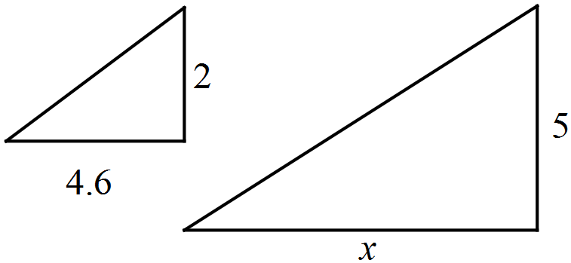

(b) The two triangles shown below are similar. Determine the lengths  and . (3 marks)

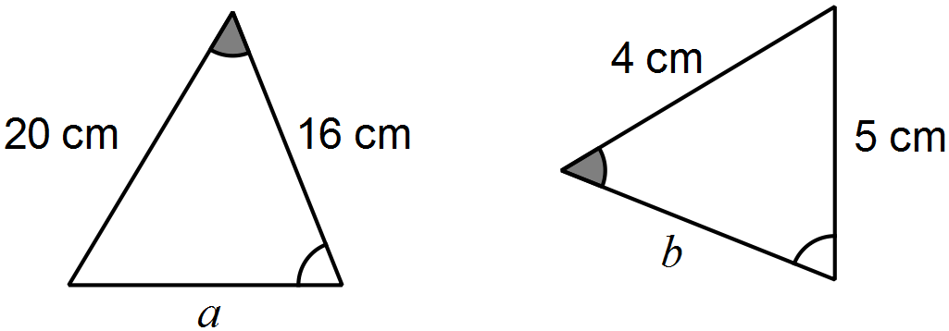



(c) An image, with one side that is 13 cm long, is enlarged so that the same side now measures 39 cm. If the original area of the image was 200 cm2, determine the area of the enlargement. (3 marks)



Question 7 (7 marks)

A system of one-way and two-way paths connects three locations A, B and C. There may be more than one path between any two locations. The table below shows the number of ways to travel between these locations using a single path.

|  |  |  |  |  |
| --- | --- | --- | --- | --- |
|  |  | To | | |
|  |  | A | B | C |
| From | A | 0 | 1 | 1 |
| B | 0 | 0 | 2 |
| C | 2 | 2 | 0 |

(a) Is the path between A and B one-way or two-way? Justify your answer. (1 mark)

One-way from A to B, as from B to A there are no ways but from A to B there is one way.

(b) Complete the network diagram below to show the information in the table. (2 marks)

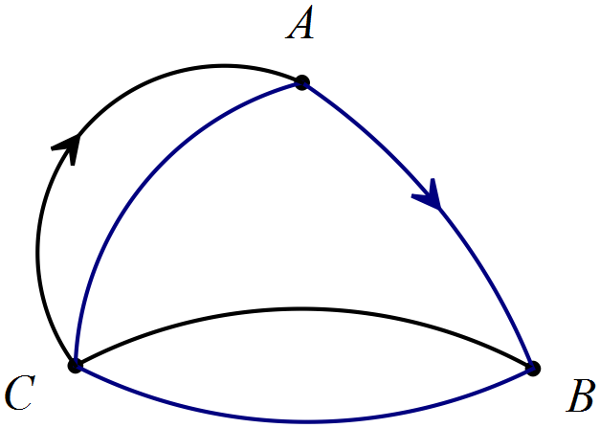

(c) Arrange the information from the table in a matrix  and determine the matrix .

(3 marks)



(d) How many ways exist to travel from B to A using two paths? (1 mark)

4

Additional working space

Question number: _________

This examination paper may be freely copied, or communicated on an intranet, for non-commercial purposes within educational institutes that have purchased the paper from WA Examination Papers provided that WA Examination Papers is acknowledged as the copyright owner. Teachers within Rossmoyne Senior High School may change the paper provided that WA Examination Paper's moral rights are not infringed.

Copying or communication for any other purposes can only be done within the terms of the Copyright Act or with prior written permission of WA Examination papers.

*Published by WA Examination Papers*

*PO Box 445 Claremont WA 6910*